Experiment design:
For the purpose of testing the scalability of the proposed architecture, a set of experiments was conducted, focusing on analysing the impact the number of nanopublications has on the cluster ingestion capability, responsiveness under querying workload, and overall resource consumption.

All experiments were set up following the procedure:
- A set of 4 registries and 4 query instances were configured in the closed network, initialized with the content of the nanopublications network.
- A set of 100,000 nanopublications was generated and submitted to the cluster by 9 parallel processes, each submitting nanopublications with no artificial delays and imitating 50 nanodash users.
- After the ingestion of 100,000 nanopublications, the querying workload was simulated. For 20 minutes, pubkey repositories were queried by a total of 24 concurrent users. Queries used for workload simulation are given below.

Nanopublications generation procedure aimed to follow a natural behavioral pattern of users, with a small number of users being the most active; hence, the Pareto distribution for users authoring nanopublications was adopted. In addition to that, the generation covered multiple nanopublication types, such as: making a plain assertion (a new nanopublication with a simple assertion), updating an existing nanopublication, retracting an existing nanopublication, and commenting on an existing nanopublication. The weights of these types in the generation process were as follows: plain assertion - 0.6, comment - 0.3, update - 0.05, and retraction - 0.05.

The querying workload simulation followed a similar design, adopting 3 queries with varying weights – 3, 1, and 2, for Query 1, 2, and 3, respectively:

Query 1:
prefix npa: <http://purl.org/nanopub/admin/>
select * where {
npa:thisRepo npa:hasNanopubCount ?count .
}
Query 2:
prefix np: <http://www.nanopub.org/nschema#>
select (count(*) as ?count) where {
?subject ?predicate ?object .
}
Query 3:
prefix npx: <http://purl.org/nanopub/x/>
select ?type (count(?np) as ?count) where {
?np npx:hasNanopubType ?type .
} group by ?type

Experiment 1:

Experiment 1 featured 4 registries replicating their nanopublications as they are ingested. In this scenario, all nanopublications were submitted to the general registry service, which used a scheduler to round-robin incoming nanopublications, distributing the load among 4 identically configured registries.

This experiment consisted of 4 phases, each consisting of 100,000 nanopublications ingestion followed by a 20-minute querying workload.

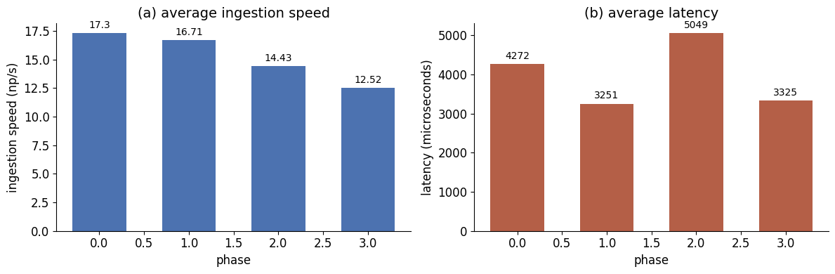

It is seen, that, as the number of nanopublications increases, the ingestion speed decreases. Yet, no clear change can be observed in the querying latencies.

Infrastructure metrics for average CPU usage are shown in Figure[X], further providing insight into how the total number of nanopublications impacts resource usage during ingestion and querying.

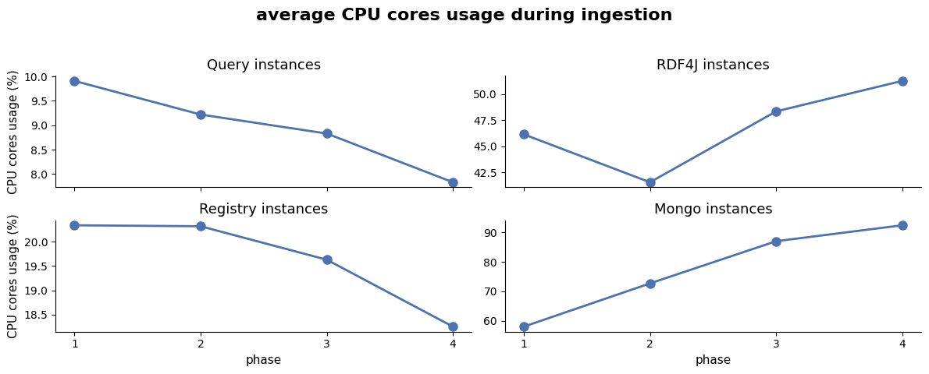
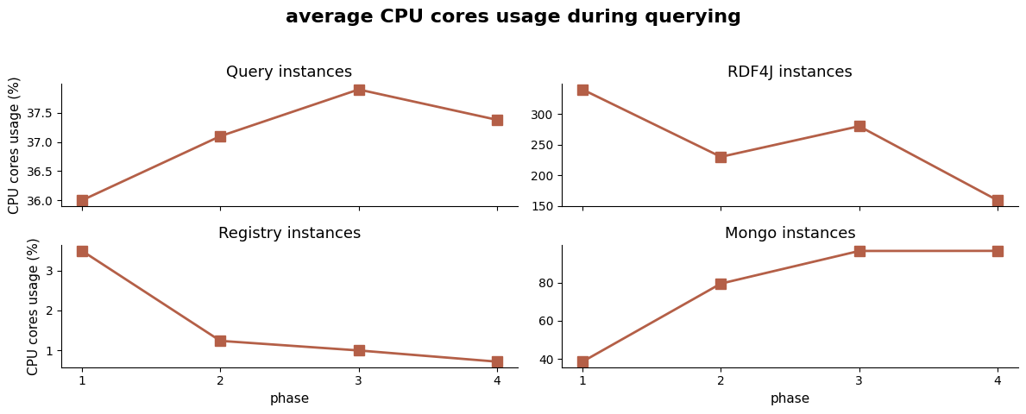

It can be observed that, as the number of nanopublications increases, RDF4J and Mongo instances' CPU usage increases during ingestion, while Registry and Query instances' CPU usage decreases slightly. For the querying workload, the most drastic change can be observed for RDF4J instances' CPU usage, as it decreases from 340% to 159%, while Mongo instances experience an increase in CPU usage from 39% to 97%.

Experiment 2:

Experiment 2 featured an updated cluster configuration. The registries were updated to cover only a fixed subset of 100 nanopublication types. The coverage configured registries to accept the following types:
- Registry 1 — types 0 to 49
- Registry 2 — types 25 to 74
- Registry 3 — types 50 to 99
- Registry 4 — types 75 to 99 and 0 to 24

In addition to that, all registries accepted retraction and comment nanopublications.

The ingestion speed and latency compared with the previous experiment are illustrated in Figure [X].

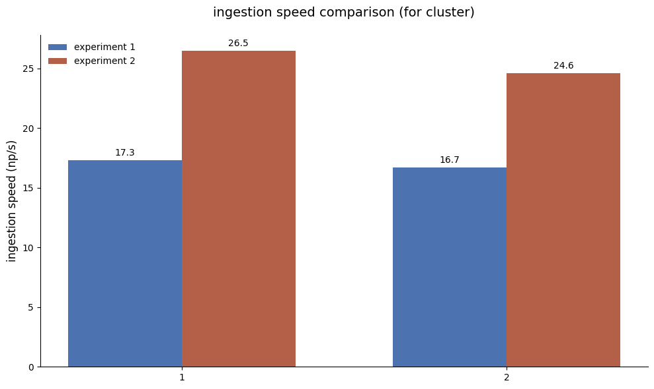

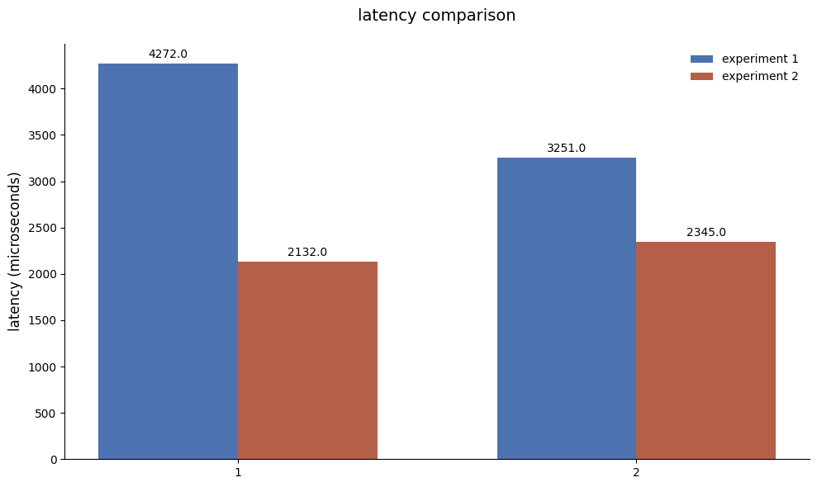

It is seen that, on the cluster level, nanopublications were ingested faster, i.e., the total time needed for ingesting all 100,000 new nanopublications decreased in the new setup. Similarly, querying latency decreased in the new setup.

Furthermore, comparison of the average CPU usage (Figure [X]), reveals that [compare metrics]

